Lab02-Constructors-
Destructors

Lab02-Constructors-Destructors
VNU-HCM, HCMUS, FIT, SE
CS202 - Programming Systems
25A01 - 02
DINH Ba Tien, PhD TRUONG Phuoc Loc, MSc HO Tuan Thanh, MSc

A: YY: 02
H: YY: 07

For assignment 01 — 04, please do the following tasks:
- Implement at least 5 constructors. Also add a cout statement to show that the method in called.
- Implement the destructor. Also add a cout statement to show that the method in called.
- Implement a toString()
- Implement a clone() method to create a new object having values as the existing object. It works like the copy constructor.
Finally, in the main function, create a series of objects and output them to the console. Run the program and inspect the output.
For example, with the Point2D class:
- 5 constructors
  - Point2D();
  - Point2D (int x);

  - Point2D (int x, int y);
  - Point2D (const Point2D &other);
  - Point2D (string s); // s = “15,-2”
  - cout statement: cout << “Point2D::Default cons” << endl;
- Destructor: Point2D();
  - cout statement: cout << “Point2D::Destructor” << endl;
- toString() method: Point 15, -2 » string “15,-2)
- clone() method: p2 = p1.clone();

Assignment 1
Class. Point2D: x, y

Assignment 2
Class Triangle: Point2D A, B, C

Assignment 3
Class MyIntArray: int*a, int n

Assignment 4
Student: int id, char* fullname, char* address, double gpa

Assignment 5
Draw a class diagram and write a program in C++ with OOP style that can be used by a small theater to sell tickets for performances. The theaterʼs auditorium has 15 rows of seats, with 30 seats in each row. The program should display a screen that shows which seats are available and which are taken. For example, the following screen shows a chart depicting each seat in the theater. Seats that are taken are represented by an * symbol, and seats that are available are represented by a # symbol:

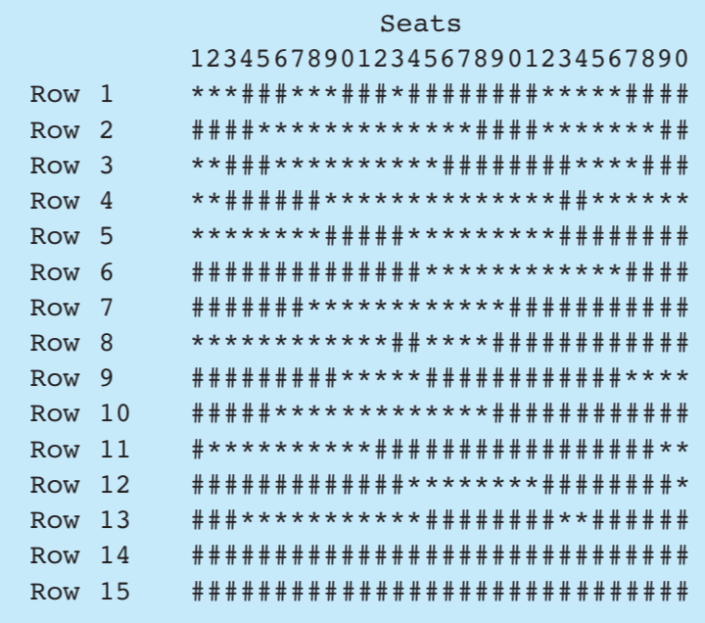

Here is a list of tasks this program must perform:
- When the program begins, it should ask the user to enter the seat prices for each row. The prices can be stored in a separate array. (Alternatively, the prices may be read from a file.)
- Once the prices are entered, the program should display a seating chart similar to the one shown above. The user may enter the row and seat numbers for tickets being sold. Every time a ticket or group of tickets is purchased, the program should display the total ticket prices and update the seating chart.
- The program should keep a total of all ticket sales. The user should be given an option of viewing this amount.
- The program should also give the user an option to see a list of how many seats have been sold, how many seats are available in each row, and how many seats are available in the entire auditorium.
Input Validation: When tickets are being sold, do not accept row or seat
numbers that do not exist. When someone requests a particular seat, the program should make sure that seatis available beforeitissold.

Assignment 6
Write a presentation (Markdown format) with at least 20 slides to explain the following OOP topics in Python:
- Constructor
- Destructor

Assignment 7
Write a presentation (Markdown format) with at least 20 slides to explain the following OOP topics in Java:
- Constructor
- Destructor

